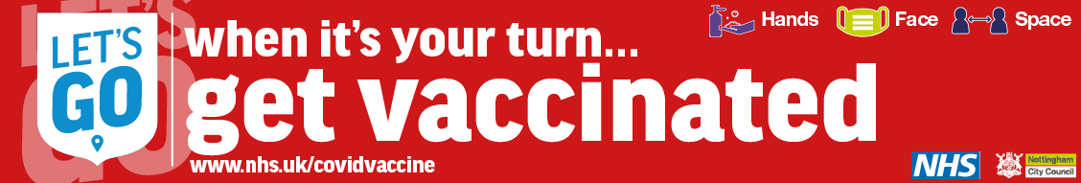
27 May 2021
Dear Parents and Carers
‘Grab your jab’ and help to keep Nottingham Schools safe
We’re making a fresh call for all eligible adults in Nottingham to get vaccinated against Covid-19.
We want everyone to have the protection offered by the vaccine to reduce the spread of the virus – and to help the city’s continued unlocking of Covid-19 restrictions.
The more people who take up the offer of a vaccine, the greater the protection afforded to all local communities and our schools. Like you, we want to move towards 21 June when all remaining social restrictions might be lifted by the Government.
We don’t want to return to lockdown.
Currently, everyone over the age of 30 can get the vaccine – to book your appointment, visit www.nhs.uk/covidvaccine or call 119.
Anyone over the age of 40 does not need to book; they can simply turn up to any of our local vaccination centres.
We want everyone to have the vaccine.
We understand that there may be valid reasons for people to be a little unsure or hesitant about having the jab. If you haven’t yet taken up the opportunity to be vaccinated, you haven’t missed your opportunity; anyone can change their mind. The NHS currently has a good supply of the vaccine – plenty for everyone in our city who is eligible.
People might also be concerned about the Covid-19 variant that originated in India. Latest research shows the vaccine is still effective against this variant.
If you have questions, the local NHS has a webpage with lots of frequently asked questions and mythbusters.
You can find a list of the vaccination centres here.
It is important families continue to follow national guidance and when not showing any symptoms conduct twice weekly testing using free, rapid COVID tests. This identifies those unseen cases that can still spread the infection. Please visit www.nottinghamcity.gov.uk/asymptomatictesting for further information.
Let’s all work together to keep each other safe and protected so that we can move forward out of this pandemic.

Cllr David Mellen David Johns
Leader Interim Director of Public Health
Nottingham City Council Nottingham City Council

